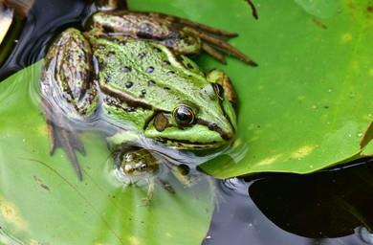

Stage 1: Eggs.

Eggs are laid in a group in the water by the frog. These then hatch into tadpoles. A female frog can lay up to 4000 eggs at one time! These eggs float on water in ponds, lakes, and rivers, and look like a large mass of jelly. These eggs are known as frog spawn and will hatch into Tadpole.

Stage 2: Tadpole.

When the eggs hatch, tadpoles emerge. The tadpole spends time eating and growing. When tadpoles are young they look a lot more like fish than frogs. They have gills that allow them to breathe underwater. As tadpoles grow, hind limbs emerge, and they soon begin to look like small frogs with tails. They also develop lungs so they can breathe out of the water and can spend time on land.
Stage 3: Young frog

The frog grows front legs and its tail gradually becomes shorter until it is no longer there. This young froglet is ready to jump out of the water to experience life on land.

Stage 4: Adult frog

As the frog develops into an adult, it will begin to eat insects. It can take up to four years before the frog becomes fully mature. The frog can lay eggs or fertilize them, and thee life cycle of a frog can start all over again.
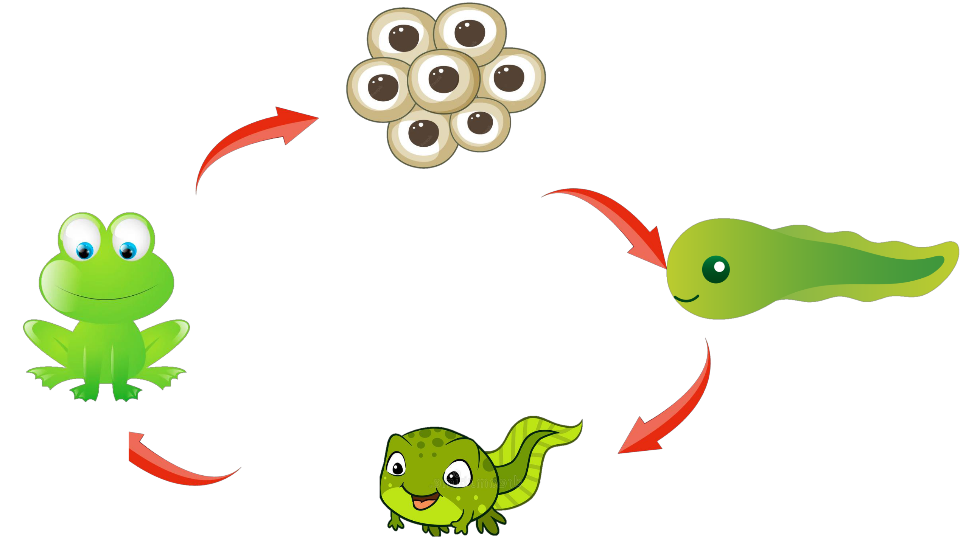

Puzzle

Arrange the following according to the stages of frog
